**PAPER TITLE (use style: PAPER TITLE)**

First Author1, Second Author2, Corresponding author3* (use style: unabbreviated first name, middle name initials, last name e.g. John AK Smith1, Edward Jones2)

1First Affiliation name of department and organisation, City, Country   
2Second Affiliation name of department and organisation, Address, City, Country   
3Third Affiliation name of department and organisation, Address, City, Country

4Current affiliation name of department and organisation, Address, Country   
*email address of corresponding author

**Keywords**: Enter a maximum of five keywords here (use style: KEYWORD ONE, KEYWORD TWO, …)

Abstract

The abstract should be suitable for direct inclusion in abstracting services as a self-contained article. The length of the abstract should not exceed 200 words. Do not include figure numbers, table numbers, references or displayed mathematical expressions

1 Introduction

This document, saved in the “Word 97-2003” format, is a guide to using the Manuscript Template. Before submitting your final paper, check that the format conforms to this guide. In particular, check the text to make ensure that the correct referencing style has been used and that the citations are in numerical order throughout the text. Your manuscript cannot be accepted for publication unless all formatting requirements are met.

*1.1 Manuscript formatting requirements*

*1.1.1 Title:* The main title of the paper should be 18pt, Full Capital letters and centred.

***1.1.2 Author Names and Affiliations:*** author names and affiliations should immediately follow the title. To avoid confusion, use the format: first name, middle name initials, family (last) name (e.g. John A.K. Smith). The inclusion of middle name initials is not mandatory. Author details must not show any professional title (e.g. Managing Director), any academic title (e.g. Dr.) or any membership of any professional organisation.

For multiple-authored articles, list the full names of all the authors, using identifiers to link an author with an affiliation where necessary (e.g. John AK Smith1, Edward Jones2).

The full affiliations of all authors should be listed underneath the author affiliations. Affiliations should include: the department name; the name of the university or company; the name of the city; and the name of the country (e.g. 1Department of Electrical Engineering, University of Sydney, Sydney, Australia).

If an author's present address is different from the address at which the work was carried out, this should be given as a secondary affiliation (see affiliation 4 (above)).

*1.1.3 Language, Spelling and Grammar:* all papers must be written in UK English.. Papers that fail to meet basic standards of literacy are likely to be declined. Ensure that the paper is spell checked.

*1.1.4 Paper Length:* the length of the full paper should not exceed eight A4 pages.

*1.1.5 Page Formatting:* comply with the requirements stated and demonstrated in this Manuscript Template. A PDF will be created automatically on the manuscript submission system. Authors should not copy or re-use the format of other published papers.

*1.1.6 Page Layout:* the paper must be in double column format, 8.8cm wide with margin separation of 0.4 cm, and single spacing. This can be achieved by setting the left and right margins to 1.5 cm wide. All paragraphs must be justified, i.e. both left-justified and right-justified. This template as it stands has the correct pay layout required.

Page numbers shall be placed in the ‘page footers’ on all pages. No other information is to be placed in the footer.

*1.1.7 Text Font:* standardised fonts such as Times, Times Roman, Times New Roman or Symbol are to be used with a font size no smaller than 10pt.

*1.1.8 Section Headings:* all section heading should be numbered and no more than 3 levels (e.g. 1,1.1 and 1.1.1) of headings should be used.

The headings of each section that should be used are as follows:

**First Level Headings**

The first level section headings should be in bold font, 12pt (e.g. “**1 Introduction**”), with the paragraph starting on a new line.

*Second Level Headings*

The second level section headings should be in italic font 10pt (i.e. “*2.3 Section Headings*”). The paragraph should start on a new line.

*Third Level Headings:* the third level section headings should also be in italic font but should end with a colon (:). The text for that section should run on and not start as a new paragraph

2. Methodology

Enter methodology section here.

3 Results

*3.1 Figures*

Graphics may be full colour but make sure that they are appropriate for print (black and white) and online (colour) publication. Coloured line graphs should use dotted or dashed lines, or shapes to distinguish them apart in print. Examples of graphs in acceptable formats are given in Fig 1. Each figure should be explicitly referred to in numerical order and should be embedded within the text at the appropriate point. A maximum of four subfigures are allowed per figure.

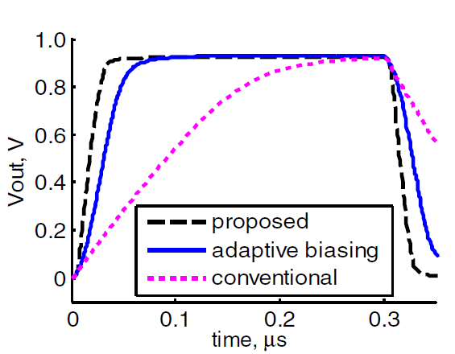

*a*

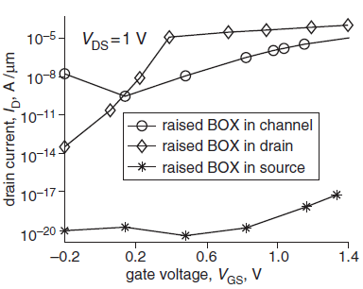

*b*

*3.1.1 Figure Captions:* two examples of figure captions in an acceptable format for Fig 1.are given below:

Fig. 1 (a) Sample graph with pink (dotted), blue (solid) and black (dashed) lines, (b) Sample graph with black (diamond), black (triangle) and black (square) markers

**or**

Figure 1 Sample graph

(a) Subfigure 1

(b) Subfigure 2

Figure captions must be below the figure, in 10pt font and should ideally consist of one sentence. If a figure has subfigures, all subfigures should also have a caption and should be identified by letters, e.g. (*a)*, (*b)*, (*c), (d)* as shown above.

*3.2 Tables*

Tables should be formatted as shown in the example below with no column lines, unless these are essential for clarifying the content of the table. Row lines can be used to distinguish the column headings from the content of the table.

Table 1 Example table

|  |  |  |
| --- | --- | --- |
| Column heading | Column heading two | Column heading three |
|  | | |
| Row 1 | Row 1 | Row 1 |
| Row 2 | Row 2 | Row 2 |

*3.2.1 Table Captions:* tables must be numbered and cited within the text in strict numerical order. Table captions must be above the table and in 10 pt font.

*3.3 Mathematical equations*

* Equations should fit into a two-column print format and be single spaced.
* When writing mathematics, avoid confusion between characters that could be mistaken for one another, e.g. the letter 'l' and the number one.
* Vectors and matrices should be in bold italic and variables in italic.
* If your paper contains superscripts or subscripts, take special care to ensure that the positioning of the characters is unambiguous.
* Exponential expressions should be written using superscript notation, i.e. 5x103 not 5E03.
* A multiplication symbol should be used, not a dot.
* Refer to equations using round brackets e.g. (1)

*3.4 Units*

* Use SI (MKS) units only and avoid spelling the unit in full instead of using the shortened notation e.g. use kJ not kilo Joules.
* If for any reason you must use mixed units, the units used for each quantity in an equation must be stated.
* Place a zero before decimal points: “0.10” do not put “.10.”

4 Conclusion

Submissions should always include the following sections: an abstract; an introduction; a conclusion and a references section. If any of the above sections are not included the paper will be unsubmitted and you will be asked to add the relevant section.

5 Acknowledgements

Acknowledgements should be placed after the conclusion and before the references section. Details of grants, financial aid and other special assistance should be noted.

6 References

*6.1 Referencing Style*

You should number your references sequentially throughout the text, and each reference should be individually numbered and enclosed in square brackets (e.g. [1]).

If the number of authors on a reference is greater than three list the first three authors followed by et al.

Ensure that all references in the Reference list are cited in the text and vice versa. Failure to do so may cause delays in the production of your article.

Ensure that you provide as much information as possible to allow the reader to locate the article concerned. This is particularly important for articles appearing in conferences, workshops and books that may not appear in journal databases.

Do not include references for papers that have been submitted and not accepted for publication. Papers that have been accepted for publication are allowed as long as all information is provided.

Provide all author name(s) and initials, title of the paper, date published, title of the journal or book, volume number, editors (if any), and finally the page range. For books and conferences, the town of publication and publisher (in parentheses) should also be given.

**Example References**

*6.2 Referencing Examples*

**Journal articles**

[5] Smith, T., Jones, M.: 'The title of the paper', IET Syst. Biol., 2007, 1, (2), pp. 1–7

[6] Borwn, L., Thomas, H., James, C., et al.:'The title of the paper, IET Communications, 2012, 6, (5), pp 125-138

**Conference Paper**

[7] Jones, L., Brown, D.: 'The title of the conference paper'. Proc. Int. Conf. Systems Biology, Stockholm, Sweden, May 2006, pp. 1–7

**Book, book chapter and manual**

[8] Hodges, A., Smith, N.: 'The title of the book chapter', in Brown, S. (Ed.): 'Handbook of Systems Biology' (IEE Press, 2004, 1st edn.), pp. 1–7

[9] Harrison, E.A., and Abbott, C.: 'The title of the book' (XYZ Press, 2005, 2nd edn. 2006)

**Patent**

[11] Brown, F.: 'The title of the patent (if available)'. British Patent 123456, July 2004

**Report**

[10] IET., 'Report Title' (Publisher, 2013), pp. 1-5

[12] Smith, D., Hodges, J.: British Patent Application 98765, 1925

**Standard**

[14] BS1234: 'The title of the standard', 2006

**Thesis**

[13] Abbott, N.L.: 'The title of the thesis'. PhD thesis, XYZ University, 2005

**Websites**

[1] ‘Author Guide - IET Research Journals’, http://digital-library.theiet.org/journals/author-guide, accessed 27 November 2014

[2] ‘Research journal length policy’, http://digital-library.theiet.org/files/research_journals_length_policy.pdf, accessed 27 November 2014

[3] ‘ORCID: Connecting research and researchers’, http://orcid.org/, accessed 3 December 2014

[4] ‘Fundref’, http://www.crossref.org/fundref/, accessed 4 December 2014